**Documentation file for Capstone Project on Axon Company**

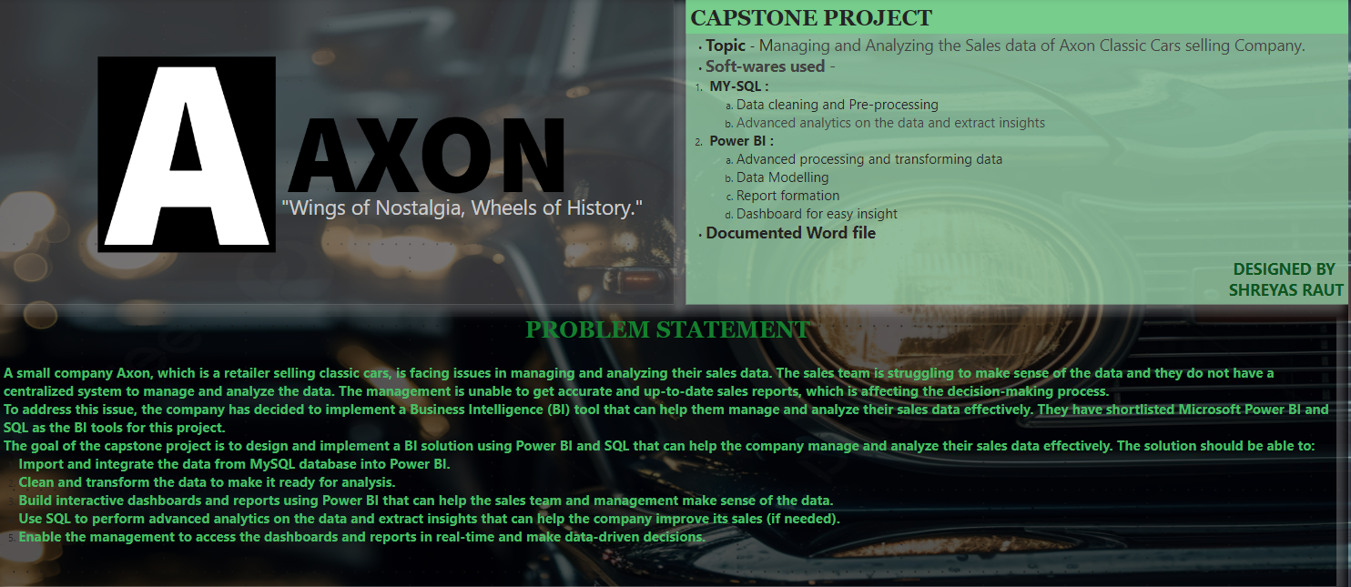

* **Topic** - Managing and Analysing the Sales data of Axon Classic Cars selling Company.
* **Soft-wares used** -

1. **MY-SQL :**
2. Data cleaning and Pre-processing
3. Advanced analytics on the data and extract insights
4. **Power BI :**
5. Advanced processing and transforming data
6. Data Modelling
7. Report formation
8. Dashboard for easy insight

* **Documented Word file**

**PROBLEM STATEMENT**

A small company Axon, which is a retailer selling classic cars, is facing issues in managing and analysing their sales data. The sales team is struggling to make sense of the data and they do not have a centralized system to manage and analyse the data. The management is unable to get accurate and up-to-date sales reports, which is affecting the decision-making process.

To address this issue, the company has decided to implement a Business Intelligence (BI) tool that can help them manage and analyse their sales data effectively. They have shortlisted Microsoft Power BI and SQL as the BI tools for this project.

The goal of the capstone project is to design and implement a BI solution using Power BI and SQL that can help the company manage and analyse their sales data effectively. The solution should be able to:

1. Import and integrate the data from MySQL database into Power BI.
2. Clean and transform the data to make it ready for analysis.
3. Build interactive dashboards and reports using Power BI that can help the sales team and management make sense of the data.
4. Use SQL to perform advanced analytics on the data and extract insights that can help the company improve its sales (if needed).
5. Enable the management to access the dashboards and reports in real-time and make data-driven decisions.

**PROCEDURES**:

1. Loading the provided data to MY-SQL.
2. **MY-SQL** :
   1. Basic Data Cleaning and Pre-processing
   2. Organised the columns like the Name , Address etc.
   3. Analysing the data with required Queries.
3. Loading the data to Power BI
4. **Power BI**:
   1. Transformation : Transformed the data in Power query editor
      1. Worked on null and blank values
      2. Checked on with the data types of the variables
      3. Checked on with the headers
      4. Removed duplicates
   2. Data Modelling – Modelled the tables in the data
      1. Identified the Model to be Snowflakes and worked on it accordingly.
      2. Converted the many to many relationship between a few tables to many to one by removing the duplicates from the dimension tables.
      3. Joined the tables using appropriate common column from the tables.
      4. Analysed Fact table – ‘Order details’ table and dimension tables
   3. Analysing Tables:
      1. Calculation part in the Fact table
         1. Calculated **Sales column**
         2. Brought Buy price column from the Products table using ‘Related’ function.
         3. Calculated **Profit column** using buy price and price each columns.
      2. Calculation in Products table
         1. Calculated **Profit margin** using MSRP and buy price columns
         2. Calculated **Profit per Product** using MSRP and buy price columns
   4. Dashboard:- Using appropriate Format, Filters and Visualization to fetch the insights from the Data.
      1. PAGE 1
         1. Project Details
            1. Company Name and Logo
            2. Problem Statement for the Capstone Project
         2. Personal Detail
      2. PAGE 2
         1. Interactive Sales and Profit Visualisation like Total Sales and Profit and its relative status with other variables like Product Line etc.
         2. Sales and Profit with respect Product Name and Order Dates, Year, months
      3. PAGE 3
         1. Devolution of stats with respect to Product Line.
      4. PAGE 4
         1. Devolution of stats with respect to Product Line, Country etc.
      5. PAGE 5
         1. Products and their respective analysis using stats like the most expensive products, top products with sales and profits etc.
      6. PAGE 6:
         1. Details on customers and their purchases from the company
         2. Customers and respective details like the country they are based in, credit limit offered, and their Purchase from the Axon company.